Group of Popular Girls Reduces Nation to Tears
NEWS October 30, 2016
Vol 45 Issue 44
NEW YORK—A group of popular teenage girls viciously insulted the United States Tuesday, causing the populace to break down and cry following assertions that its 300 million citizens are stupid and fat and that everybody hates them.
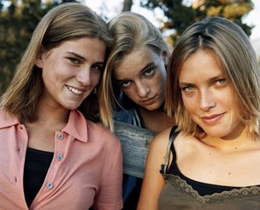
Ashley, Courtney, and Marisa find endless new ways to crush the fragile American populace.
The elite clique, which consists of high school sophomores Ashley Powell, Courtney Hughes, and Marisa Reynolds, reportedly preyed on the nation's insecurities by mocking the way Americans were dressed and proclaiming that every U.S. resident was "a complete loser."
"Those girls are so cruel," said Pittsburgh construction worker Joe Miller, wiping away tears from his eyes. "They made all these really mean comments about my weight and the way I smelled, and then one of them, I think it was Courtney, said that the color of my hard hat really brought out the ugliness in my face."
Added Miller, "I don't ever want to go back to that construction site!"
Sources confirmed the entire Midwest was filled with self-doubt after the girls ridiculed the region by yawning in an exaggerated manner and declaring that everything its citizens had to say was "bor-ing."
In addition, the girls' merciless attacks left the state of Nebraska so mortified that all its residents stayed home the next morning, unable to go about their daily routines for fear of what the teenagers might be telling others about them.
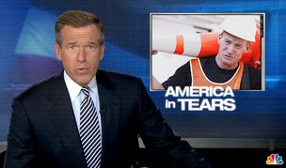
Reporting on the fate of a construction worker, Brian Williams warns viewers not to make direct eye contact with the popular 16-year-olds.
The exclusive trio of 16-year-olds was reportedly at its most ruthless while tormenting the nation's women, upsetting millions by spreading malicious rumors that every one of them was a complete slut. Ashley Powell, who publicly stated that they all looked like huge fucking cows, is believed to be responsible for traumatizing the Eastern Seaboard and leaving all its female residents completely inconsolable.
"They do this every time," said 51-year-old Portland, ME resident Sandra Thompson, who takes a different route to work each day in order to avoid the mean-spirited clique. "You leave the house thinking you look great. Then they invite you over, smile that little perky smile of theirs, and tell you that your new skirt almost hides your huge ass."
Social worker Janet Martin, who said the popular teens were only using derision to overcome low self-esteem, sobbed with her hands covering her face after the girls made fun of her low salary, meager benefits, and lack of career-advancement opportunities.
According to sources in his office, Houston mayor Bill White received an anonymous handwritten note from the teenagers last week stating that someone "super hot" had a huge crush him. When White followed the instructions in the message and arrived Saturday at the Willowbrook Mall food court holding a single red rose, he was embarrassed to discover the person waiting for him was Julie, that one fat girl with the braces.
Though an overwhelming majority of the country fears being ostracized by the popular girls, many admitted they wished they could do something, anything, to be noticed by them.
"It's like they don't even know I'm alive," said John Green, 91, of Miami. "I don't know why I let it bother me. I've lived a rich, rewarding life. But they're so pretty, and their hair is so perfect!"
"Why don't they like me?" Davis continued. "What did I ever do to them?"
Even President Barack Obama wasn't spared from the popular teens' contempt.
"I was working hard on a plan to reduce U.S. oil consumption, and they were just sitting there smirking and pointing at me the whole time," said Obama, who overheard the girls whispering that he shouldn't have bailed out the U.S. auto industry without first calling for stronger provisions to improve fuel efficiency. "But that's how they operate. They find one little flaw in your energy policy and relentlessly make fun of you for it."
"They're probably laughing at me right now," Obama added. "I hate those girls!"
At press time, the group of girls reiterated its long-held stance that no one in the nation has any friends. When asked for further comment, the teenagers pointed at reporters, giggled, and said, "Whatever."

